Quick Guide – Applications
This quick guide provides information on the application process for VET Student Loans.

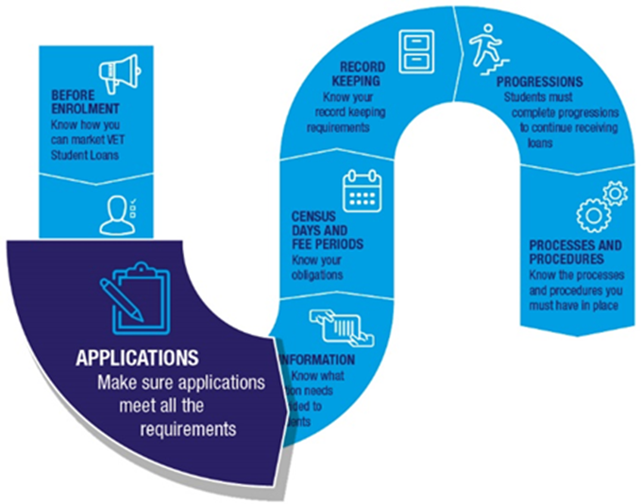

Applying for a VET Student Loan

The VET Student Loan application process
- After enrolling in a VET Student Loans approved course, a student informs their provider that they want to access a VET Student Loan.
- The provider assesses the student’s eligibility for a loan (refer to Quick Guide – Eligibility). If assessed as eligible, the provider enters the student’s enrolment information into the electronic Commonwealth Assistance Form (eCAF) system.
- The eCAF system sends an email to the student with instructions on how to access their application.
- The student completes the pre-populated eCAF, including providing their Tax File Number (TFN). For students under 18 additional information is required. Refer to ‘Students who are under 18’ below.
- A student cannot submit an eCAF earlier than two business days after the enrolment date in the eCAF system. This ensures that students have adequate time to consider their decision to take on a loan.
- The eCAF must be submitted on or before the census day for which they want the loan to apply.
- After submitting the eCAF, the student receives a receipt via email with confirmation that the application has been approved. The provider can now view the student’s eCAF.
- The application process is now complete. The student will be able to access a VET Student Loan, paid to the provider, for any census days that occur after the eCAF submission date.

Students who are under 18
Students who are under 18 must submit a completed parental consent form as part of their application. This parental consent form needs to be signed by a responsible parent.
If the student does not submit a completed parental consent form then they will be unable to access a VET Student Loan unless they can prove that they are independent (see section below).
You can find the parental consent form on the Department of Education, Skills and Employment (the department) website.

When is a student under 18 considered independent?
A student under 18 years of age is considered independent if they have received Youth Allowance on the basis that they are independent. They will need to provide evidence of this to their provider. This evidence is best provided by the student’s Centrelink Income Statement that notes that they have been assessed as independent.
A student who is under 18 that can prove their independence does not need to submit a parental consent form as part of their application.
If a student cannot show appropriate evidence of their independence, they will need to submit a signed parental consent form to access a VET Student Loan.

eCAFs
Applications for VET Student Loans are made through the electronic Commonwealth Assistance Form (eCAF) system.
To access the eCAF system, providers must complete the eCAF System Access Request form for each individual officer requesting access to the system, and/or the eCAF API System Access Request form for a provider service account. The completed forms must be sent to VETStudentLoans@dese.gov.au.
Answers to frequently asked questions can be found under the ‘Help’ tab in the eCAF system.
Providers must supply accurate student enrolment information in the eCAF. If there are inaccuracies, students will be directed to their provider for correction.
Providers cannot delete an eCAF once it has been submitted by a student. However, a provider may delete an eCAF that has not been submitted by a student if the student no longer wishes to access a VET Student Loan.

Tax File Numbers (TFNs)
To apply for a VET Student Loan a student needs to have a valid TFN.
If a student cannot remember their TFN they should call the Australian Taxation Office (ATO) on
13 28 61. Providers cannot request or obtain a student’s TFN directly from the ATO.
If a student does not have a TFN, they will need a Certificate of Application for a Tax File Number to apply for a VET Student Loan. This is a certificate from the ATO that shows that a student has applied for a TFN. The student must attach this certificate to their eCAF before submitting it to the department.
Once the student receives their TFN from the ATO they need to contact their provider immediately. The provider will need to re-open the eCAF to allow the student to update their TFN.
To do this, the provider puts the eCAF into ‘revision’ status. The student will receive an email telling them to update their eCAF record with their TFN. After entering their TFN, the student resubmits the eCAF.
This process must be done within six weeks of the ‘First census day of the loan application’ in the eCAF. Without a TFN, the student will not be able to use the loan to pay their fees.
Without a TFN included in the eCAF, providers will not be paid the loan amount and providers cannot recover the course fee from students. Providers cannot recover course fees from the student where those fees were indicated in the Statement of Covered Fees as being covered by a loan.
To allow providers to follow up on students who have supplied a Certificate of Application for a Tax File Number, providers can run an eCAF exception report to identify all students who have not yet provided a TFN. The report is available on the eCAF dashboard. Providers may also access and search for eCAFs without TFNs directly in the eCAF system or via the API links from their student management systems. Refer to the eCAF Help guide for more information.

Required documentation
Providers must retain all required information and documentation collected in relation to a VET Student Loan application for five years. Providers must be able to produce this evidence and documentation for the department on request.
Further information
For further information on applications, refer to the following resources:
- VET Student Loans Manual for Providers (see Chapter 4.7 Student Administration and Chapter 4.8 Processes and Procedures)
- VET Student Loans Information Booklet
For the legislation relating to application requirements, please see sections 10, 17 and 51-52 of the VET Student Loans Act 2016, and sections 10, 85, 105 and 152 of the VET Student Loans Rules 2016.
Contacts
If you need assistance with the eCAF system, please contact: VETStudentLoans@dese.gov.au.

