Quick Guide – Information Requirements
This quick guide helps providers to understand what information they must provide to students.
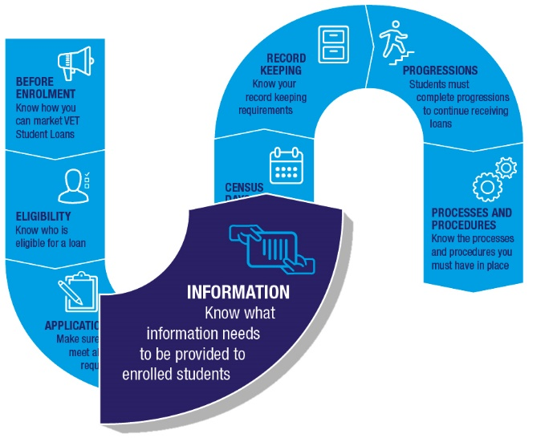

Information to be provided to students

Information to be provided before enrolment
Providers must give students a range of information before their enrolment in a VET Student Loans approved course. This includes information about course fees, census days and provider processes.
The information must be given to all students planning to study an approved course, including those who do not plan to access a VET Student Loan.
Refer to section 98 of the VET Student Loans Rules 2016 for the full list of information providers must give students prior to enrolment.

Statement of Covered Fees
Tuition fees covered by a VET Student Loan are known as ‘covered fees’. After enrolling in a course, but before the course’s first census day, providers must give students a Statement of Covered Fees. It must be titled ‘VET Student Loan Statement of Covered Fees’.
This statement records whether the student’s enrolment is made on the basis that all or part of their tuition fees will be covered by a VET Student Loan.
Some students will only want to use a loan to pay for part of their fees. For these students, the statement must show how much of their tuition fees will, and will not, be covered by a loan.
The Statement of Covered Fees must also include other information, including:
- the student’s name, residential address, phone number and email address
- the provider’s name, any other business name they use and their registered training organisation (RTO) registration code
- the date of the statement
- the student’s student identification number issued by the provider
- the student’s Commonwealth Higher Education Student Support Number (CHESSN), if available
- the student’s unique student identifier (USI)
- the name of the course.
Providers need to ensure that their Statement of Covered Fees meets legislative requirements. These requirements can be found in section 56 of the VET Student Loans Act 2016 and section 129 of the VET Student Loans Rules 2016.
Providers should note that the Statement of Covered Fees can be given to students with the Fee Notice for the first fee period of the course (see below).

Fee Notice
Providers must give students a VET Student Loans Fee Notice at least 14 days before the first census day for each fee period of a course. This means students should receive multiple Fee Notices during their studies.
Fee Notices must be given to all students enrolled in a VET Student Loans approved course. This includes students who do not wish to access a VET Student Loan. Only students who are clearly not eligible for VET Student Loans, such as international students, do not need to be given a Fee Notice.
More than one census day can be included in a Fee Notice. For example, a provider may give one Fee Notice for a whole term or semester of study. However, providers may not give the Fee Notice to students more than 42 days before the beginning of the fee period. This rule does not apply to providers who are public universities.
Information that must be included in the Fee Notice can be found at subsection 99(4) of the
VET Student Loans Rules 2016. It includes things such as fees for the course, as well as student and provider details. Providers should be careful to ensure their Fee Notices are in line with legislative requirements.

Commonwealth Assistance Notice
A Commonwealth Assistance Notice (CAN) must be given to all students accessing a VET Student Loan for their course. The CAN must be given on or within 28 days after each census day during the course. This means students should receive multiple CANs during their studies. A CAN may be given for more than one census day if it still meets the 28 day rule.
The CAN must include information on the student’s loan, the tuition fees for the course, as well as provider and student details. The full requirements for what must be included in the CAN can be found at paragraph 100(4) of the VET Student Loans Rules 2016.
Providers should be careful to ensure their Commonwealth Assistance Notices are in line with legislative requirements.

How to provide notices
The Fee Notice and the CAN must be sent to students in one of three ways. They must be sent to either:
- the student’s personal email
- the student’s postal address
- to the student by another method agreed to by the student.
An email address issued to the student by a provider is not considered the student’s personal email address.

Further information
For further information on information requirements for providers, refer to the VET Student Loans Manual for Providers (see chapter 4.11 Provision of Information to Students).
For the legislation governing the requirements to give information to students, please see sections 50 and 56-57 of the VET Student Loans Act 2016, and sections 98-100 and 129 of the VET Student Loans Rules 2016.

